Project Design Phase-II
Data Flow Diagram & User Stories

Date | 28 September 2026
Team ID | SWTID-2026-5152
Project Name | AI FitWell – AI Personalized Fitness, Wellness and Meals Planner
Maximum Marks | 4 Marks

Data Flow Diagrams:
A Data Flow Diagram (DFD) for AI FitWell represents how user requests move through the Express API, authentication middleware, application modules, MongoDB, and the Gemini AI service. It shows the major data inputs, processing components, and storage used by the implemented backend.

AI FitWell DFD – Simplified
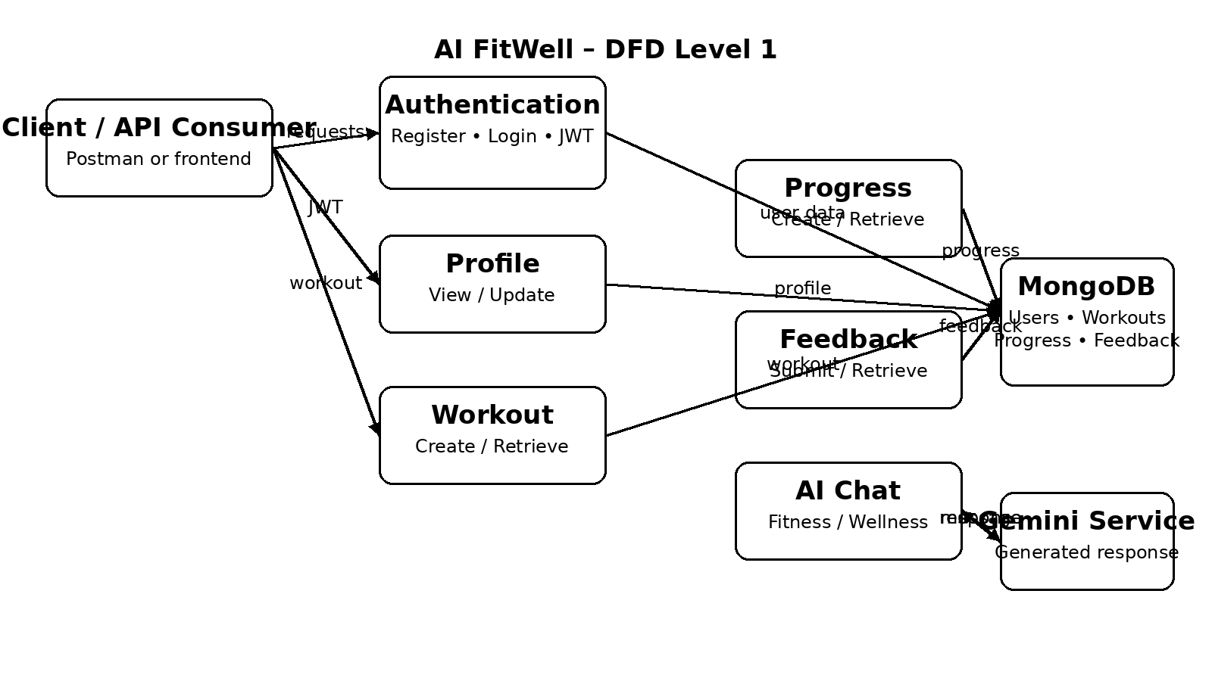

User Stories
Use the below template to list the user stories implemented by the AI FitWell project.

User Type | Functional Requirement (Epic) | User Story Number | User Story / Task | Acceptance criteria | Priority | Release
Authenticated User | Authentication | USN-1 | As a user, I can register for AI FitWell using my name, email and password. | A user account is created and a userId is returned. | High | Sprint-1
Authenticated User | Authentication | USN-2 | As a user, I can log in using my registered email and password. | A JWT token and userId are returned after successful login. | High | Sprint-1
Authenticated User | Profile | USN-3 | As a user, I can view my profile information. | The authenticated user's profile is returned without the password. | High | Sprint-1
Authenticated User | Profile | USN-4 | As a user, I can update my fitness profile information. | Valid profile fields are updated and saved. | Medium | Sprint-1
Authenticated User | Workout Management | USN-5 | As a user, I can add a workout record. | Workout name, category, duration, calories and date are stored. | High | Sprint-1
Authenticated User | Workout Management | USN-6 | As a user, I can view my workout history. | The user's workout records are retrieved from MongoDB. | High | Sprint-1
Authenticated User | Progress Tracking | USN-7 | As a user, I can record my fitness progress. | Weight, exercise, water and date values are stored. | High | Sprint-1
Authenticated User | Progress Tracking | USN-8 | As a user, I can view my progress history. | The user's progress records are retrieved in date order. | High | Sprint-1
Authenticated User | Feedback | USN-9 | As a user, I can submit a rating and written feedback. | A rating from 1–5 and feedback message are saved. | Medium | Sprint-2
Authenticated User | Feedback | USN-10 | As a user, I can retrieve my submitted feedback. | The user's feedback records are returned. | Medium | Sprint-2
Authenticated User | AI Assistance | USN-11 | As a user, I can send a fitness or wellness message to the AI assistant. | Gemini returns a fitness/wellness response through the AI endpoint. | High | Sprint-2
Authenticated User | Security | USN-12 | As a user, protected APIs should reject unauthorized requests. | Requests without valid authentication are rejected. | High | Sprint-1

